**UNIT-I**

**Fundamentals of electric Circuits:** Introduction, Classification of network elements, Voltage-Current relations for passive elements, Kirchhoff's laws, Series-Parallel connection, Source transformation-Star-Delta transformation, Simple problems.

**Introduction**

**What is an electrical circuit?**

An **electric circuit** is a path in which electrons from a voltage or current source flow. The point where those electrons enter an **electrical circuit** is called the "source" of electrons.

**What do you mean by electrical network?**

An **electrical network** is an interconnection of **electrical** components (e.g. batteries, resistors, inductors, capacitors, switches) or a model of such an interconnection, consisting of **electrical** elements (e.g. voltage sources, current sources, resistances, inductances, capacitances).

**How do electrons flow around a circuit?**

**Current** only **flows** when a **circuit** is complete—when there are no gaps in it. In a complete **circuit**, the electrons **flow** from the negative terminal (connection) on the power source, through the connecting wires and components, such as bulbs, and back to the positive terminal.

**Current:** An electric current is a flow of electric charge (electrons).

Unit of Electric current is **Ampere**

Electric current is measured using a device called an **ammeter.**

**Voltage:** Voltage is the electromotive force or the electrical potential (Charge) difference between two points in a circuit.

Unit of Voltage is **volt**

Voltage is measured using a device called **voltmeter.**

**Classification of network elements**

The circuit elements are classified into following categories,

1. Passive and active elements
2. Unilateral and Bilateral elements
3. Linear and Non-Linear elements

**Passive and Active Elements**

**Passive Element**: The elements that absorbs or stores energy is called passiveelement.

` Examples: Resistor (R), Capacitor (C), Inductor (L), Transformer

**Active Element**: The elements that supply energy to the circuit is called activeelement.

Examples: Voltage and Current sources, Generators, Transistor.

**Unilateral and Bilateral Element**

**Bilateral Element**: Conduction of current in both directions in an element withsame magnitude is termed as bilateral element.

Examples: Resistance; Inductance; Capacitance

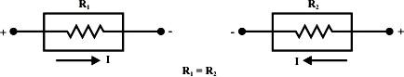

**Unilateral Element**: Conduction of current in one direction in an element istermed as unilateral element

Examples: Diode, Transistor.

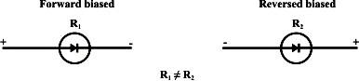

**Linear and Non Linear Elements**

**Linear Element**: The elements that obeys ohm’s law and homogeneityprinciple is called linear element.

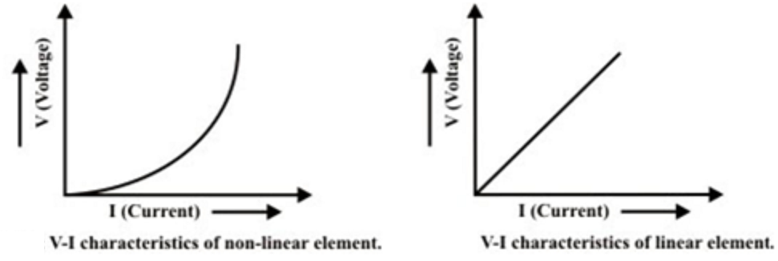**Examples:** Resistor (R), Capacitor (C), Inductor (L)

**Non-Linear Element**:The elements that does not obey ohm’s law andhomogeneity principle is called Non-Linear element.

**Examples:** Semiconductors

**Voltage-Current relations for passive elements**

**Resistor:**

**Resistance (R):** The opposition offered to the flow of electric current flowing through the material is called Resistance.

Unit: Ohm (Ω)

**Laws of Resistance:**

Electrical resistance (R) of a conductor is

1. directly proportional to its length, l i.e. R ∝ l,
2. inversely proportional to its area of cross-section, a i.e.

http://www.electrical4u.com/wp-content/uploads/2013/03/resistivity0.gif

Combining these two laws we get,

http://www.electrical4u.com/wp-content/uploads/2013/03/resistivity1.gif

Where ρ is a constant depending on the nature of the material of the conductor and is known as it’s Specific Resistance or Resistivity.

**Specific Resistance or Resistivity:**

**Specific Resistance or Resistivity** is the resistance of a material with unit length and unit cross sectional area.  
**Unit:**

The **unit of resistivity** can be easily determined form its equation

http://www.electrical4u.com/wp-content/uploads/2013/03/resistivity2.gif

**Conductance:**

 It is the inverse of resistance. $G= \frac{1}{R}$

**Unit:**

$G= \frac{1}{Ω}=mho$ (or) siemen

**Conductivity:**

 It is the inverse of resistivity. $σ= \frac{1}{ρ}$

**Unit:**

$σ= \frac{1}{Ω-m}=mho/m$ (or) Siemen/m

**Factors affecting the Resistance:**

**1. Length of the material:**

The Resistance “R” is directly proportional with its length: **“L”**

**R ∝ l**

As length of the wire increases, resistance also increases.

**2. Cross Sectional Area of the material:**

The Resistance “R” is inversely proportional with its Cross Sectional Area: **“A”**

**http://www.electrical4u.com/wp-content/uploads/2013/03/resistivity0.gif**

As Cross Sectional Area of the wire increases, resistance also decreases.

**3. Nature of the material:**

The Resistance “R” is dependent on the Nature of the material.

* In Conductors, No of free electrons are very high so resistance of the conductor is very less.
* In Insulators and Semiconductors, No of free electrons are less so resistance of the conductor is very high.

**4. Temperature of the conductor:**

The Resistance “R” is dependent on the Temperature of the conductor.

**R2 = R1 (1 + α*ΔT)**

Where ‘α’ is the temperature coefficient of resistance

* For Conductors **‘α’ = +ve, as** temperature increases, resistance also increases.
* For Insulators and Semiconductors **‘α’ = -ve, as** temperature increases, resistance decreases.

**Ohm’s law:**

***At a constant temperature the voltage across a conducting material is directly proportional to the current flowing through it.***

According to definition



$V ∝I$

$V=IR$

Where, V = Voltage across the conductor in volts

I = Current flowing through the conductor in Ampere

R = Proportionality constant (resistance in ohms)

**I-V Characteristics of Resister**

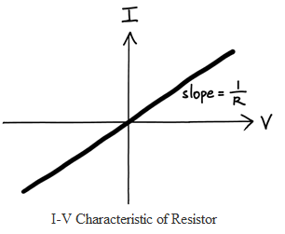

Power consumed by Resister, P=VI=V2/R=I2R

Energy consumed by Resister, W=VIt = V2t/R=I2Rt

## Inductor

The property of the coil of inducing emf due to the changing flux linked with it is known as **inductance of the coil**. Due to this property all electrical coil can be referred as **inductor**.

In other way, an inductor can be defined as an energy storage device which stores energy in form of magnetic field.

Whenever a time-changing current is passed through a coil or wire, the voltage across it is proportional to the rate of change of current through the coil. This proportional relationship may be expressed by the equation is

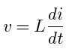

Where L is the constant of proportionality known as inductance and is measured in Henrys (H).

Remember v and i are both functions of time.

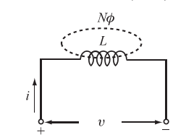

Figure: Model of the inductor

Let us assume that the coil shown in Figure has N turns and the core material has a high permeability so that the magnetic flux Ф is connected within the area A. The changing flux creates an induced voltage in each turn equal to the derivative of the flux Ф, so the total voltage v across N turns is

 ------🡪 1

Since the total flux NФ is proportional to current in the coil,

We have NФ = Li -------🡪 2

Where L is the constant of proportionality. Substituting equation (2) into equation (1), we get



The power in an inductor is



The energy stored in the inductor is

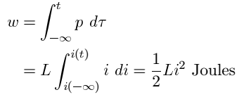

Note that when  Also note that w(t)>=0 for all i(t), so the inductor is a passive element. The inductor does not generate energy, but only stores energy.

**Capacitor**

A capacitor is a two-terminal element that is a model of a device consisting of two conducting plates separated by a dielectric material. Capacitance is a measure of the ability of a device to store energy in the form of an electric field.

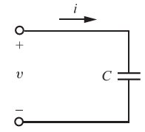

Figure: Circuit symbol for a capacitor

Capacitance is defined as the ratio of the charge stored to the voltage difference between the two conducting plates or wires



The current through the capacitor is given by



The energy stored in a capacitor is

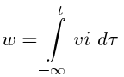

Remember that v and i are both functions of time and could be written as v(t) and i(t).

Since



We have

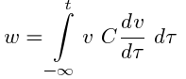

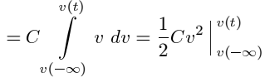

Since the capacitor was uncharged at 

Hence

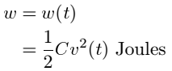

Since q =Cv we may write



Note that since w(t) >= 0 for all values of v(t), the element is said to be a passive element.

**Kirchhoff's laws**

**Kirchhoff’s Current Law (KCL)**

***Kirchhoff’s Current Law states that the algebraic sum of the current meeting at a node (junction) is equal to zero***

i.e., ∑ I =0

This law is illustrated below. Five branches are connected to node O which carries currents I1, I2, I3, I4 and I5 as shown in Figure. Consider current entering (I1, I3 & I5) to the node as positive and current leaving (I2 & I4) from the node as negative.



Figure: Five branches are connected to node ‘o’

From above diagram

-I1- I2+ I3+ I4+ I5=0

or

I1+ I2= I3+ I4+ I5

i. e., Incoming currents = Outgoing currents

Hence Kirchhoff’s first law can be stated as:

***The currents flowing towards any junction in an electric circuit is equal to the sum of the currents flowing away from the junction***

**Examples:**

Find out the value of unknown current I from the given networks

Example 1



Where incoming currents are 5A and 10A, outgoing current is I. By applying KCL at node o

$$I-5-10=0$$

or

$$I=15 A$$

**Unknown current I = 15A**

Example 2



Where incoming currents are I, 10A and 5A

By applying KCL at node o

$$-I-5-10=0×$$

or

$$I=-15 A$$

**Unknown current I =** -**15A**

This minus sign indicates that the actual current direction is opposite.

**Kirchhoff’s Voltage Law (KVL)**

***The algebraic sum of the all branch voltages in a loop (or closed path) is equal to zero***

or

**Kirchhoff’s Voltage Law *states that in a closed circuit, the algebraic sum of all source voltages must be equal to the algebraic sum of all the voltage drops.***

**Steps to follow**

Step 1: Mark all the nodes

Step 2: Mark all branch currents

Step 3: Mark voltage drop across each resistor (mark current entering point as positive

and current leaving point as negative).

Step 4: Depend up on the number of unknowns write KVL equations (At the time of

writing equations consider the sign which see first for the voltage drops and

voltage sources)

Step 5: By solving this equations calculate the unknown branch currents and determine

the desired responses.

**Illustration of Kirchhoff’s law**

Apply KVL and determine current flowing through each element.



**Solution,**



Step 4 – Write KVL equations

From loop – ABCDA

$$V_{1}+V_{2}+V_{3}+V_{4}-V=0………………………….(1)$$

From ohm’s law

$V_{1}=I×R_{1}, { V}_{2}=I×R_{2},{ V}_{3}=I×R_{3} \& V_{4}=I×R_{4},$ Substitute these values in to equation 1.

$$I×R_{1} + I×R_{2}+I×R_{3}+I×R_{4}-V=0$$

$$I×{(R}_{1} + R_{2}+R_{3}+R_{4})=V$$

$$I=\frac{V}{{(R}_{1}+ R_{2}+R_{3}+R_{4})}$$

**Example:**

Find out the value of unknown current I from the given networks





$$I=\frac{V}{{(R}_{1}, + R_{2}+R_{3}+R_{4})}$$

Step 4 – Write KVL equations

From loop – ABCDA

$$V_{1}+V_{2}+V_{3}+V_{4}-V=0………………………….(1)$$

From ohm’s law

$$V_{1}=I×100, { V}_{2}=I×50,{ V}_{3}=I×25 \& V_{4}=I×25,$$

Substitute these values in to equation 1.

$$I×100+I×50+I×25+I×25,-200=0$$

$$I×{(100+50+25+25}_{1})=200$$

$$I=\frac{200}{200}=1A$$

**Series-Parallel connection**

With simple series circuits, all components are connected end-to-end to form only one path for the current to flow through the circuit:

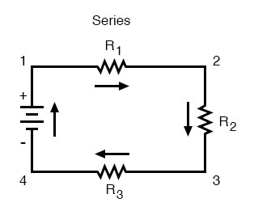 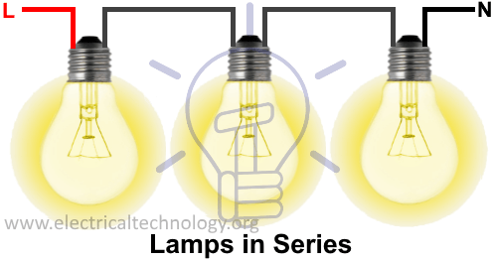

With simple [parallel circuits](https://www.allaboutcircuits.com/video-lectures/parallel-circuits/), all components are connected between the same two sets of electrically common points, creating multiple paths for the current to flow from one end of the battery to the other:

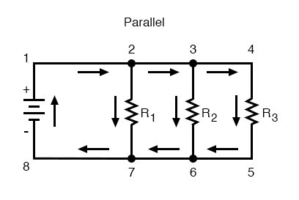 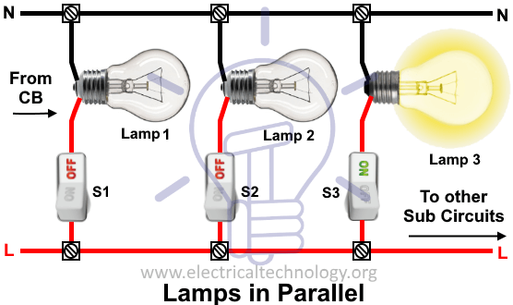

### Rules regarding Series and Parallel Circuits

With each of these two basic circuit configurations, we have specific sets of rules describing [voltage, current, and resistance](https://www.allaboutcircuits.com/video-lectures/electrical-quantities-a/) relationships.

**Series Circuits:**

* Voltage drops add to equal total voltage.
* All components share the same (equal) current.
* Resistances add to equal total resistance.

**Parallel Circuits:**

* All components share the same (equal) voltage.
* Branch currents add to equal total current.
* Resistances diminish to equal total resistance.

### Series - Parallel Circuits

However, if circuit components are series-connected in some parts and parallel in others, we won’t be able to apply a single set of rules to every part of that circuit. Instead, we will have to identify which parts of that circuit are series and which parts are parallel, then selectively apply series and parallel rules as necessary to determine what is happening. Take the following circuit, for instance:

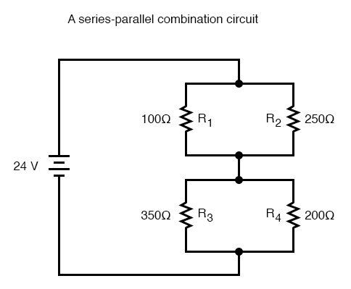 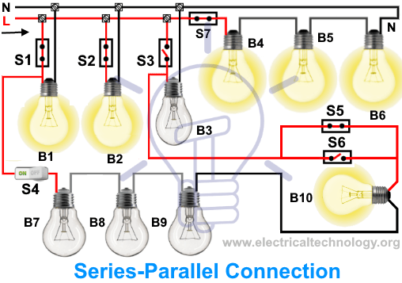

This circuit is neither simple series nor simple parallel. Rather, it contains elements of both. The current exits the bottom of the battery splits up to travel through R3 and R4, rejoins, then splits up again to travel through R1 and R2, then rejoin again to return to the top of the battery. There exists more than one path for current to travel (not series), yet there are more than two sets of electrically common points in the circuit (not parallel).

Because the circuit is a combination of both series and parallel, we cannot apply the rules for voltage, current, and resistance “across the table” to begin analysis like we could when the circuits were one way or the other. For instance, if the above circuit were simple series, we could just add up R1 through R4 to arrive at a total resistance, solve for total current, and then solve for all voltage drops. Likewise, if the above circuit were simple parallel, we could just solve for branch currents, add up branch currents to figure the total current, and then calculate total resistance from total voltage and total current. However, this circuit’s solution will be more complex.

The table will still help us manage the different values for series-parallel combination circuits, but we’ll have to be careful how and where we apply the different rules for series and parallel. [Ohm’s Law](https://www.allaboutcircuits.com/video-lectures/electrical-quantities-b/), of course, still works just the same for determining values within a vertical column in the table.

If we are able to identify which parts of the circuit are series and which parts are parallel, we can analyze it in stages, approaching each part one at a time, using the appropriate rules to determine the relationships of voltage, current, and resistance. The rest of this chapter will be devoted to showing you techniques for doing this.

[**https://www.electricaltechnology.org/2015/03/parallel-connection-is-preferred-over-series.html**](https://www.electricaltechnology.org/2015/03/parallel-connection-is-preferred-over-series.html)

|  |  |
| --- | --- |
| **Difference Between Series and Parallel Circuits** | |
| **Series** | **Parallel** |
| The same amount of current flows through all the components | The current flowing through each component combines to form the current flow through the source. |
| In an electrical circuit, components are arranged in a line | In an electrical circuit, components are arranged parallel to each other |
| When resistors are put in a series circuit, the voltage across each resistor is different even though the current flow is the same through all of them. | When resistors are put in a parallel circuit, the voltage across each of the resistors is the same. Even the polarities are the same |
| If one component breaks down, the whole circuit will burn out. | Other components will function even if one component breaks down, each has its own independent circuit |
| If Vt is the total voltage then it is equal to V1+V2+V3 | If Vt is the total voltage then it is equal to V1=V2=V3 |

**Resistors in Series**

Consider the series combination of N resistors shown in Figure. To simplify the circuit with replacing the N resistors with a single resistor Req so that the remainder of the circuit, in this case only the voltage source, does not realize that any change has been made. The current, voltage, and power of the source must be the same before and after the replacement.

First, apply KVL:

**vS =v1+v2+···+vN**

and then Ohm’s law:

**vS =R1i +R2i +···+RNi =(R1+R2+···+RN)i**

Now compare this result with the simple equation applying to the equivalent circuit shown in Figure:

**v­S =Reqi**

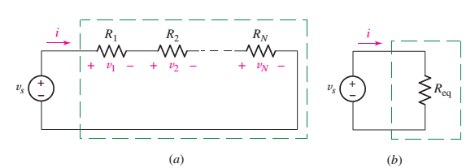

Thus, the value of the equivalent resistance for N series resistors is

**Req =R1+R2+···+RN**

**Voltage Division**

Voltage division is used to express the voltage across one of several series resistors in terms of the voltage across the combination. In Figure, the voltage across R2 is found via KVL and Ohm’s law:

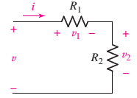**v=v1+v2=iR1+iR2=i(R1+R­2)**

So



Thus



Or



and the voltage across R1 is, similarly,



If the network of Figure is generalized by removing R2and replacing it with the series combination of R2, R3............RN, then we have the general result for voltage division across a string of N series resistors

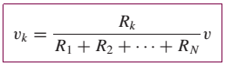

which allows us to compute the voltage **vk** that appears across an arbitrary resistor Rk of the series.

**Resistors in Parallel**

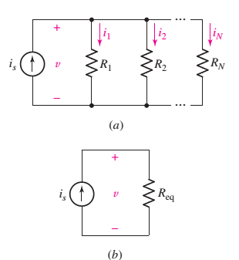Similar simplifications can be applied to parallel circuits. A circuit containing N resistors in parallel, as in Figure, leads to the KCL equation

**iS =i1+i2+···+iN**

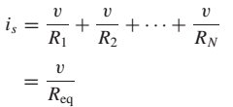

or, in terms of conductances, as

**Geq =G1+G2+···+GN**

The simplified (equivalent) circuit is shown in Figure.

**Current Division**

The dual of voltage division is current division. We are now given a total current supplied to several parallel resistors, as shown in the circuit of Figure.

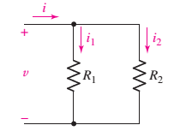The current flowing through R2 is



Or

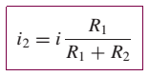

and, similarly,

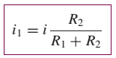

For a parallel combination of N resistors, the current through resistor Rk is

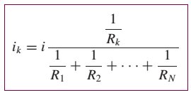

**Source Transformation**

An **electrical source transformation** (source transformation) is a method for simplifying circuits by replacing a voltage source with its equivalent current source, or a current source with its equivalent voltage source. Source transformations are implemented using [Thévenin’s theorem](https://www.electrical4u.com/thevenin-theorem-and-thevenin-equivalent-voltage-and-resistance/) and [Norton’s theorem](https://www.electrical4u.com/norton-theorem-norton-equivalent-current-and-resistance/).

**Source transformation** is a technique used to simplify an electric circuit.

**Example:**

Let’s take a simple [voltage source](https://www.electrical4u.com/voltage-source/) along with a [resistance connected in series](https://www.electrical4u.com/resistances-in-series-and-resistances-in-parallel/) with it.

This series resistance normally represents the internal resistance of a practical voltage source.

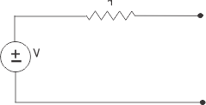

Now, let us short circuit the output terminals of the voltage source circuit as shown below,

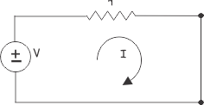

Now, applying [Kirchhoff Voltage Law](https://www.electrical4u.com/kirchhoff-current-law-and-kirchhoff-voltage-law/) in the circuit above we get,

https://www.electrical4u.com/images/2017/october17/1508036369.png

Where, I is the [current](https://www.electrical4u.com/electric-current-and-theory-of-electricity/) delivers by the [voltage source](https://www.electrical4u.com/voltage-source/) when it is short circuited.

Now, let’s take a [current source](https://www.electrical4u.com/ideal-dependent-independent-voltage-current-source/) of the same current I which produces same open-circuit [voltage](https://www.electrical4u.com/voltage-or-electric-potential-difference/) at its open terminals as shown below,

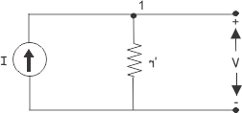

Now, applying [Kirchhoff Current Law](https://www.electrical4u.com/kirchhoff-current-law-and-kirchhoff-voltage-law/) at node 1, of the above circuit, we get,

https://www.electrical4u.com/images/2017/september17/1505994677.PNG

From equation (i) and (ii) we get,

https://www.electrical4u.com/images/2017/september17/1505994768.PNG

The open circuit voltage of both the sources is V and short circuit current of both sources is I. The same [resistance connected in series](https://www.electrical4u.com/resistances-in-series-and-resistances-in-parallel/) in voltage source is connected in parallel in its equivalent [current source](https://www.electrical4u.com/ideal-dependent-independent-voltage-current-source/).

So, these voltage source and current source are equivalent to each other.

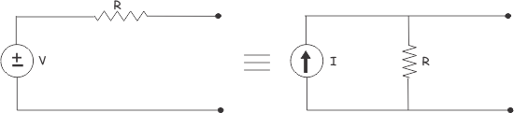

A current source is dual form of a voltage source and a voltage source is dual form of a current source.

A voltage source can be converted into an equivalent current source and a current source can also be converted into an equivalent voltage source.

### Voltage Source to Current Source Conversion

Assume a voltage source with terminal voltage V and the internal resistance r. This resistance is in series. The current supplied by the source is equal to:

https://www.electrical4u.com/images/2017/september17/1505995186.PNG

when the source of the terminals are shorted.

This current is supplied by the equivalent current source and the same resistance r will be connected across the source. The voltage source to current source conversion is shown in the following figure.

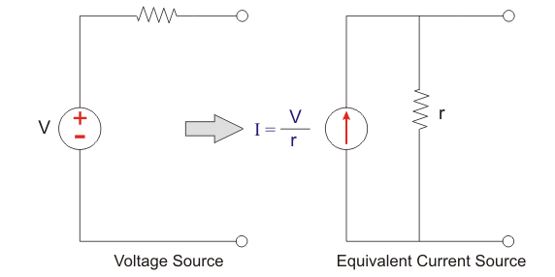

**Current Source to Voltage Source Conversion**

Similarly, assume a [current source](https://www.electrical4u.com/ideal-dependent-independent-voltage-current-source/) with the value I and internal resistance r. Now according to the [Ohm’s law](https://www.electrical4u.com/ohms-law-equation-formula-and-limitation-of-ohms-law/), the [voltage](https://www.electrical4u.com/voltage-or-electric-potential-difference/) across the source can be calculated as

https://www.electrical4u.com/images/2017/september17/1505995463.PNG

Hence, voltage appearing, across the source, when terminals are open, is V.

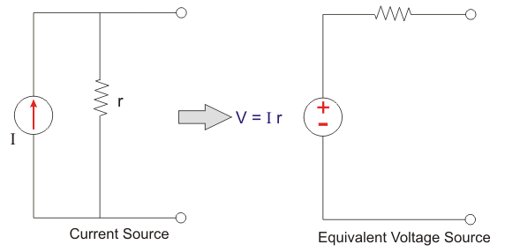

<https://www.allaboutcircuits.com/technical-articles/source-transformation/>

<https://circuitglobe.com/what-is-source-transformation.html>

• Not possible to transform ideal current (voltage) sources to ideal voltage (current) sources.

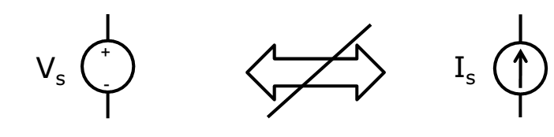

• But we can transform Practical current (voltage) sources to Practical voltage (current) sources.

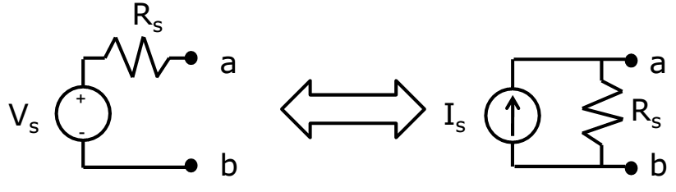

Relationships:

**IS = VS/R**

**VS = IS.R**

**Star-Delta transformation**

Three branches in an electrical network can be connected in numbers of forms but most common among them is either star or delta form. In delta connection, three branches are so connected, that they form a closed loop. As these three branches are connected nose to tail, they form a triangular closed loop, this configuration is referred as delta connection. On the other hand, when either terminal of three branches is connected to a common point to form a Y like pattern is known as star connection. But these star and delta connections can be transformed from one form to another. For simplifying complex network, delta to star or **star to delta transformation** is often required.

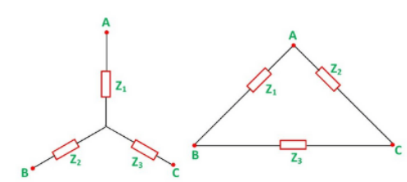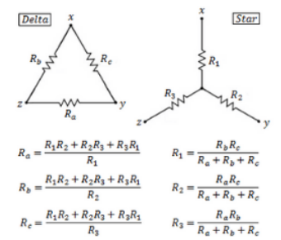

## Delta To Star Conversion

The replacement of delta or mesh by equivalent star connection is known as **delta – star transformation**. The two connections are equivalent or identical to each other if the impedance is measured between any pair of lines. That means, the value of impedance will be the same if it is measured between any pair of lines irrespective of whether the delta is connected between the lines or its equivalent star is connected between that lines.

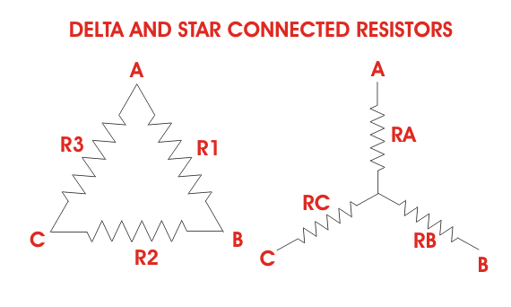

Consider a delta system that’s three corner points are A, B and C as shown in the figure. Electrical resistance of the branch between points A and B, B and C and C and A are R1, R2 and R3 respectively.

The resistance between the points A and B will be,  


Now, one star system is connected to these points A, B, and C as shown in the figure. Three arms RA, RB and RC of the star system are connected with A, B and C respectively. Now if we measure the resistance value between points A and B, we will get,  
https://www.electrical4u.com/equations/sdt-01-04-06-14.gif

Since the two systems are identical, resistance measured between terminals A and B in both systems must be equal.  
  
Similarly, [resistance](https://www.electrical4u.com/what-is-electrical-resistance/) between points B and C being equal in the two systems,  
  
And resistance between points C and A being equal in the two systems,  
  
Adding equations (I), (II) and (III) we get,  
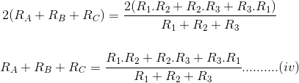  
Subtracting equations (I), (II) and (III) from equation (IV) we get,  
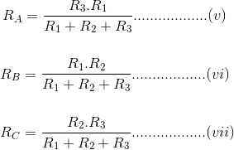  
The relation of delta – star transformation can be expressed as follows.

The equivalent star resistance connected to a given terminal, is equal to the product of the two delta resistances connected to the same terminal divided by the sum of the delta connected resistances.  
If the delta connected system has same resistance R at its three sides then equivalent star resistance r will be,



## Star To Delta Conversion

## For ****star – delta transformation**** we just multiply equations (v), (VI) and (VI), (VII) and (VII), (V) that is by doing (v) × (VI) + (VI) × (VII) + (VII) × (V) we get,

## 

## Now dividing equation (VIII) by equations (V), (VI) and equations (VII) separately we get,

## 

## <https://www.electronics-tutorials.ws/dccircuits/dcp_10.html>

### Example:

Consider the below figure to transform delta to star or Wye circuit where the values Ra = 20 ohms, R2 = 30 ohms and R3 = 50 ohms.

[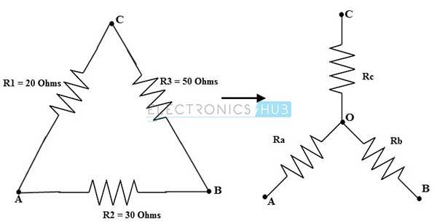](https://www.electronicshub.org/wp-content/uploads/2015/04/star-e1.jpg)

For delta to star conversions equivalent resistance equations (for this problem) are

Ra = (R1 R2)/(R1 + R2 + R3)

Rb = (R2 R3)/(R1 + R2 + R3)

Rc = (R1 R3)/(R1 + R2 + R3)

Therefore the total resistance, Rt = (R1 + R2 + R3)

= 20 + 30 + 50

= 100 ohms

Ra = (R1 R2)/(R1 + R2 + R3)

= (20 X 30) /100

= 6 ohms

Similarly Rb = (R2 R3)/(R1 + R2 + R3)

= (30 X 50) /100

= 15 ohms

and Rc = (R1 R3)/(R1 + R2 + R3)

= (50 X 20)/ 100

= 10 ohms

### Example:

Consider the below figure to transform star or Wye to the delta circuit where the resistance values in star network are given as R1= 10 ohms, R2= 5 ohms and R3 = 20 ohms.

[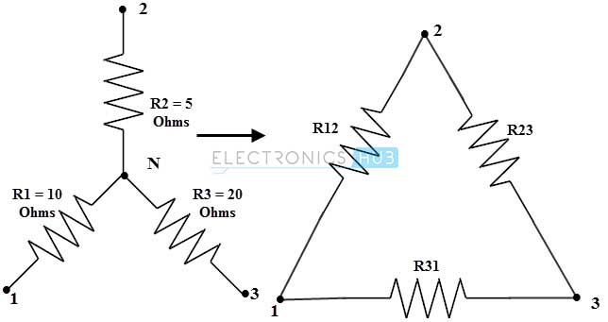](https://www.electronicshub.org/wp-content/uploads/2015/04/star-f2.jpg)

For star or wye to delta conversion, the equivalent resistance equations (for this problem) are

R12 = R1 + R2 + ((R1R2)/R3)

R23 = R2 + R3 + ((R2R3)/R1)

R31 = R1 + R3 + ((R1R3)/R2)

By simplifying the above equations we get the common numerator term as

= R1R2 + R2R3 + R1R3

= 10 X 5 + 10 X 20 + 20 X 5

= 350 ohms

Then R12 = 350/ R3

= 350/20

= 17.5 ohms

R23 = 350/ R1

= 350/ 10

= 35 ohms

R31= 350/R2

= 350 /5

= 70 ohms